

**CST2340**

**Database Systems: - Design and Implementation 2020-21**

**Coursework 1: - Part B**

**Database Implementation**

**Module Tutor: - Ms. Engie Bashir**

**Done By: -**

**Alester D’Costa (M00734829)**

**Table of Contents**

B1. Relational Model 3

B2. Relational Tables 5

B3. MySQL Statements 6

B4. Appendixes 22

i. Appendix A 22

ii. Appendix B 25

# **Relational Model**

**Millennium Dealers** is a newly scaled e-commerce company based in Dublin, Republic of Ireland. It has a presence in all areas of the country. It deals in the sale of t-shirts, shirts and hoodies of various well-known brands such as Adidas, Puma, Levi’s and many more. A website has been created by the web designer and is linked to the Millennium database developed by the database designer that helps the company in managing orders placed by various customers and the delivery of products to the customers. This would help the company in taking better business decisions and to improve its performance based on the stored data.

The company has multiple customers with their various details such as a unique ID, customer name, contact number, login email and login password. A customer places an order with details that include a unique ID, receipt id, order date, order total, order status, and receipt date. Each order has multiple stock with details that include a unique ID, color, size and quantity. Due to the company being a start-up, the customer can facilitate the payment of the order only through cash on delivery. Each stock has a single product and details of a product include a unique ID, product description, product type (i.e. t-shirt, shirt and/or hoodie), gender and price of the product. A customer may be interested in a particular brand and therefore, one brand would sell multiple products. The details of a brand include a unique ID, brand name, and country of origin. The suppliers have the responsibility of supplying the products and its details include a unique ID, supplier name, contact number, address and city. During the ordering process, the customer needs to specify his/her address. The customer may specify multiple addresses, but for a single order, only one address is taken into account based on the customers preference. The details of address include a unique ID, description, city, P.O box and address type (i.e. either a residential, company or other address).

When a customer has placed the order, the shipment process takes place within the next 3-4 business days; its details include a unique ID, delivery company name (FedEx, DHL or Aramex), date of delivery and shipment weight. An order could be delivered by one of the delivery companies and the delivery charges are free of cost.

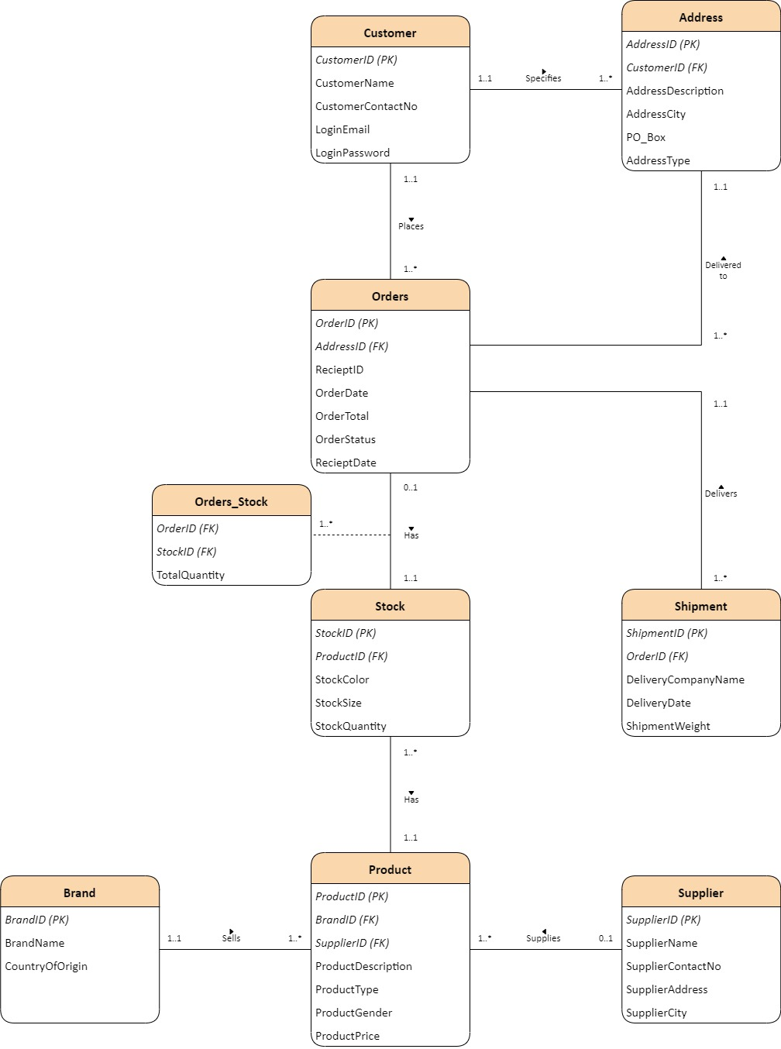

# **Relational Tables**

The following table consists of each entity as the table name and its attributes; this includes the primary key which are bold and foreign keys which have been underlined.

|  |  |
| --- | --- |
| **Table Name** | **Attributes** |
| Brand | **BrandID**, BrandName, CountryOfOrigin |
| Supplier | **SupplierID**, SupplierName, SupplierContactNo, SupplierAddress, SupplierCity |
| Customer | **CustomerID**, CustomerName, CustomerContactNo, LoginEmail, LoginPassword |
| Address | **AddressID**, CustomerID, AddressDescription, AddressCity, PO_Box, AddressType |
| Product | **ProductID**, BrandID, SupplierID, ProductDescription, ProductType, ProductGender, ProductPrice |
| Stock | **StockID**, ProductID, StockColor, StockSize, StockQuantity |
| Orders | **OrderID**, AddressID, RecieptID, OrderDate, OrderTotal, OrderStatus, RecieptDate |
| Shipment | **ShipmentID**, OrderID, DeliveryCompanyName, DeliveryDate, ShipmentWeight |
| Orders_Stock | **OrderID**, **StockID**, TotalQuantity |

# **MySQL Statements**

The schema that has been named for all records is **millenniumdb**.

/*Creates the Brand table*/

CREATE TABLE Brand(

BrandID varchar(255),

BrandName varchar(30),

CountryOfOrigin varchar(30),

CONSTRAINT pk_BrandID PRIMARY KEY(BrandID)

);

/*Load Brand with data*/

INSERT INTO Brand VALUES

("B001", "Adidas", "Germany");

INSERT INTO Brand VALUES

("B002", "Puma", "Germany");

INSERT INTO Brand VALUES

("B003", "Levi’s", "United States");

INSERT INTO Brand VALUES

("B004", "Under Armour", "United States");

INSERT INTO Brand VALUES

("B005", "Nike", "United States");

INSERT INTO Brand VALUES

("B006", "Armani", "Italy");

INSERT INTO Brand VALUES

("B007", "Calvin Klein", "United States");

/*Extract all records from Brand table*/

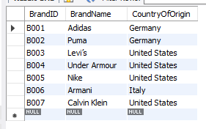SELECT * from Brand;

------------------------------------------------------------------------------------------------------------------------------------------

/*Creates the Supplier table*/

CREATE TABLE Supplier(

SupplierID varchar(255),

SupplierName varchar(60),

SupplierContactNo varchar(30),

SupplierAddress varchar(100),

SupplierCity varchar(30),

CONSTRAINT pk_SupplierID PRIMARY KEY (SupplierID)

);

/*Load Supplier with data*/

INSERT INTO Supplier VALUES

("SU001", "Caramba", "0035316001000", "Caramba Headquarters, Abbey Street", "Dublin");

INSERT INTO Supplier VALUES

("SU002", "JD Sports", "0035321006321", "JD Sports Complex, St. Patrick Street", "Cork");

INSERT INTO Supplier VALUES

("SU003", "Next", "0035342305810", "The Wallace Building, Wellington Street", "Dundalk");

INSERT INTO Supplier VALUES

("SU004", "ELIE Wholesale", "0035314009393", "The Golden Tower, Amiens Street", "Dublin");

/*Extract all records from Supplier table*/

SELECT * from Supplier;

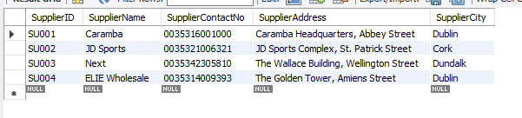

------------------------------------------------------------------------------------------------------------------------------------------

/*Creates the Customer table*/

CREATE TABLE Customer(

CustomerID varchar(255),

CustomerName varchar(60),

CustomerContactNo varchar(30),

LoginEmail varchar(30),

LoginPassword varchar(25),

CONSTRAINT pk_CustomerID PRIMARY KEY(CustomerID)

);

/*Load Customer with data*/

INSERT INTO Customer VALUES

("C001", "Conor James", "00353835674367", "conor.james@gmail.com", "Jamesalisson2020");

INSERT INTO Customer VALUES

("C002", "Cillian Anderson", "00353879648299", "cillian1989@outlook.com", "cillianA121*");

INSERT INTO Customer VALUES

("C003", "Riona Wilson", "00353867272829", "rionaw1986@yahoo.com", "Wilson.R86*");

INSERT INTO Customer VALUES

("C004", "Shane Pattinson", "00353833622445", "patto2020@outlook.com", "Pattinson88*");

INSERT INTO Customer VALUES

("C005", "Ciara Andrews", "00353832405373", "ciara2013@gmail.com", "CiaraFrancis2013");

INSERT INTO Customer VALUES

("C006", "Daniel McGregor", "00353853802023", "mdaniel1990@gmail.com", "dLeander2018*");

INSERT INTO Customer VALUES

("C007", "Cillian O’Brien", "00353871293223", "cillianob2001@yahoo.com", "obrienC2001*");

INSERT INTO Customer VALUES

("C008", "Shane Biden", "00353833833024", "shane.biden@gmail.com", "Shaneisthebest2001");

INSERT INTO Customer VALUES

("C009", "Brendan Franklin", "00353834941424", "franklinbrendan@outlook.com", "FrankBren1993*");

INSERT INTO Customer VALUES

("C010", "Grace Anderson", "00353855406832", "anderson.grace@gmail.com", "graceA1990*");

/*Extract all records from Customer table*/

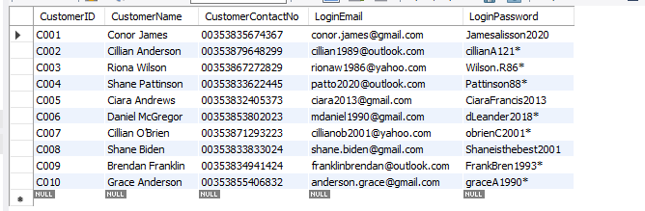SELECT * from Customer;

------------------------------------------------------------------------------------------------------------------------------------------

/*Creates the Address table*/

CREATE TABLE Address(

AddressID varchar(255),

CustomerID varchar(255),

AddressDescription varchar(100),

AddressCity varchar(20),

PO_Box varchar(5),

AddressType varchar(20),

CONSTRAINT pk_AddressID PRIMARY KEY(AddressID),

CONSTRAINT fk_CustomerID FOREIGN KEY(CustomerID) REFERENCES Customer(CustomerID)

);

/*Load Address with data*/

INSERT INTO Address VALUES

("AD001", "C001", "The Dorms Building, Building No: 15, Room No: 201, Henry Street", "Dublin", null, "Residential");

INSERT INTO Address VALUES

("AD002", "C003", "Crown Company, Building No: 43, Shandon Street", "Cork", "38923", "Company");

INSERT INTO Address VALUES

("AD003", "C001", "Leyton Traders, Greenwood Building, Building No: 99, Amiens Street", "Dublin", "28289", "Company");

INSERT INTO Address VALUES

("AD004", "C004", "The Den, Building No: 92, Flat No: 117, 14th Baker Street", "Dublin", null, "Residential");

INSERT INTO Address VALUES

("AD005", "C008", "The Italian Knights Building, Building No: 10, Flat No: 204, Leinster Street", "Dundalk", null, "Residential");

INSERT INTO Address VALUES

("AD006", "C005", "Oaklands Building, Building No: 11, Room No: 303, Leinster Street", "Dundalk", "39923", "Residential");

INSERT INTO Address VALUES

("AD007", "C008", "Francesco and Sons, Building No: 94, Baggot Street", "Dublin", "12937", "Company");

INSERT INTO Address VALUES

("AD008", "C002", "The Old Barn, Building No: 23, Flat No: 109, 24-London Street", "Galway", null, "Residential");

INSERT INTO Address VALUES

("AD009", "C007", "Leyton Traders, Greenwood Building, Building No: 99, Amiens Street", "Dublin", null, "Company");

INSERT INTO Address VALUES

("AD010", "C002", "Frankston Building, Building No: 33, Flat No: 401, Thames Street", "Cork", "84834", "Residential");

/*Extract all records from Address table*/

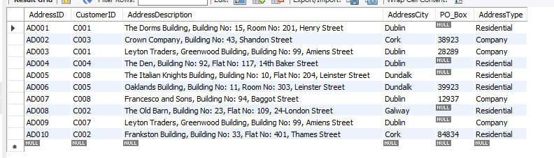SELECT * from Address;

------------------------------------------------------------------------------------------------------------------------------------------

/*Creates the Product table*/

CREATE TABLE Product(

ProductID varchar(255),

BrandID varchar(255),

SupplierID varchar(255),

ProductDescription varchar(100),

ProductType varchar(20),

ProductGender varchar(20),

ProductPrice decimal(10,2),

CONSTRAINT pk_ProductID PRIMARY KEY(ProductID),

CONSTRAINT fk_BrandID FOREIGN KEY(BrandID) REFERENCES Brand(BrandID)

);

/*Load Product with data*/

INSERT INTO Product VALUES

("P001", "B001", "SU002", "Adidas 20-21 FC Bayern Munich Away Jersey", "T-Shirt", "Male", 65.50);

INSERT INTO Product VALUES

("P002", "B003", "SU001", "Levi’s Penelope Denim Shirt", "Shirt", "Female", 20.00);

INSERT INTO Product VALUES

("P003", "B002", "SU002", "Puma Women's Amplified Fleece Hoodie", "Hoodie", "Female", 16.00);

INSERT INTO Product VALUES

("P004", "B003", "SU004", "Levi’s Men's Crewneck Graphic Short Sleeve T-Shirt", "T-Shirt", "Male", 11.00);

INSERT INTO Product VALUES

("P005", "B007", "SU003", "Calvin Klein Women’s Short Sleeve T-Shirt Monogram Logo", "T-Shirt", "Female", 20.50);

INSERT INTO Product VALUES

("P006", "B006", "SU001", "Armani Exchange Men's Crew Neck Logo Tee", "T-Shirt", "Male", 28.30);

INSERT INTO Product VALUES

("P007", "B003", "SU004", "Levi's Men's Brato Short Sleeve, Slim Fit, Solid Woven Shirt", "Shirt", "Male", 22.60);

INSERT INTO Product VALUES

("P008", "B004", "SU002", "Under Armour [Men's Tech Popover Hoodie](https://www.amazon.com/Under-Armour-1274511-Popover-Hoodie/dp/B00YSPQ5CU/ref=sr_1_9?crid=XCNF42QMN4N3&dchild=1&keywords=under+armour+hoodie+mens&qid=1606650929&sprefix=under+armour+hoo%2Caps%2C352&sr=8-9)", "Hoodie", "Male", 35.20);

INSERT INTO Product VALUES

("P009", "B002", "SU003", "Puma Unisex NRG Triblend Graphic T-Shirt", "T-Shirt", "Unisex", 25.30);

INSERT INTO Product VALUES

("P010", "B005", "SU002", "Nike 20-21 FC Barcelona Home Jersey", "T-Shirt", "Male", 60.00);

/*Extract all records from Product table*/

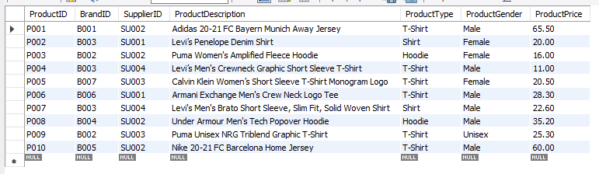SELECT * from Product;

------------------------------------------------------------------------------------------------------------------------------------------

/*Creates the Stock table*/

CREATE TABLE Stock(

StockID varchar(255),

ProductID varchar(255),

StockColor varchar(20),

StockSize varchar(20),

StockQuantity int,

CONSTRAINT pk_StockID PRIMARY KEY(StockID),

CONSTRAINT fk_ProductID FOREIGN KEY(ProductID) REFERENCES Product(ProductID)

);

/*Load Stock with data*/

INSERT INTO Stock VALUES

("S001", "P001", "White", "Small", 20);

INSERT INTO Stock VALUES

("S002", "P001", "White", "Medium", 10);

INSERT INTO Stock VALUES

("S003", "P001", "White", "Large", 10);

INSERT INTO Stock VALUES

("S004", "P001", "White", "Extra Large", 0);

INSERT INTO Stock VALUES

("S005", "P002", "Blue", "Small", 10);

INSERT INTO Stock VALUES

("S006", "P002", "Blue", "Medium", 5);

INSERT INTO Stock VALUES

("S007", "P002", "Blue", "Large", 0);

INSERT INTO Stock VALUES

("S008", "P003", "Black", "Small", 10);

INSERT INTO Stock VALUES

("S009", "P003", "Black", "Medium", 10);

INSERT INTO Stock VALUES

("S010", "P003", "Black", "Large", 8);

INSERT INTO Stock VALUES

("S011", "P004", "White", "Small", 10);

INSERT INTO Stock VALUES

("S012", "P004", "White", "Medium", 10);

INSERT INTO Stock VALUES

("S013", "P004", "White", "Large", 5);

INSERT INTO Stock VALUES

("S014", "P004", "White", "Extra Large", 5);

INSERT INTO Stock VALUES

("S015", "P005", "White", "Small", 15);

INSERT INTO Stock VALUES

("S016", "P005", "White", "Medium", 10);

INSERT INTO Stock VALUES

("S017", "P005", "White", "Large", 5);

INSERT INTO Stock VALUES

("S018", "P006", "Black", "Small", 0);

INSERT INTO Stock VALUES

("S019", "P006", "Black", "Medium", 10);

INSERT INTO Stock VALUES

("S020", "P006", "Black", "Large", 12);

INSERT INTO Stock VALUES

("S021", "P007", "Pink", "Small", 0);

INSERT INTO Stock VALUES

("S022", "P007", "Pink", "Medium", 10);

INSERT INTO Stock VALUES

("S023", "P007", "Pink", "Large", 10);

INSERT INTO Stock VALUES

("S024", "P008", "Gray", "Small", 0);

INSERT INTO Stock VALUES

("S025", "P008", "Gray", "Medium", 10);

INSERT INTO Stock VALUES

("S026", "P008", "Gray", "Large", 5);

INSERT INTO Stock VALUES

("S027", "P009", "White", "Small", 0);

INSERT INTO Stock VALUES

("S028", "P009", "White", "Medium", 1);

INSERT INTO Stock VALUES

("S029", "P009", "White", "Large", 2);

INSERT INTO Stock VALUES

("S030", "P010", "Red", "Small", 2);

INSERT INTO Stock VALUES

("S031", "P010", "Red", "Medium", 5);

INSERT INTO Stock VALUES

("S032", "P010", "Red", "Large", 2);

/*Extract all records from Stock table*/

SELECT * from Stock;

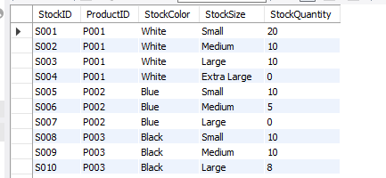

*(This table has 32 records, however only 10 records are shown in the screenshot)*

------------------------------------------------------------------------------------------------------------------------------------------

/*Creates the Orders table*/

CREATE TABLE Orders(

OrderID varchar(255),

AddressID varchar(255),

RecieptID varchar(255),

OrderDate date,

OrderTotal decimal(10,2),

OrderStatus varchar(30),

RecieptDate date,

CONSTRAINT pk_OrderID PRIMARY KEY(OrderID),

CONSTRAINT fk_AddressID FOREIGN KEY(AddressID) REFERENCES Address(AddressID)

);

/*Load Orders with data*/

INSERT INTO Orders VALUES

("OR001", "AD001", "R001", "2020-11-01", 131.00, "Order Delivered", "2020-11-03");

INSERT INTO Orders VALUES

("OR002", "AD002", "R002", "2020-11-02", 20.00, "Order Delivered", "2020-11-04");

INSERT INTO Orders VALUES

("OR003", "AD004", "R003", "2020-11-03", 22.00, "Order Delivered", "2020-11-05");

INSERT INTO Orders VALUES

("OR004", "AD008", "R004", "2020-11-03", 85.30, "Order Delivered", "2020-11-05");

INSERT INTO Orders VALUES

("OR005", "AD009", "R005", "2020-11-05", 28.30, "Order Delivered", "2020-11-07");

INSERT INTO Orders VALUES

("OR006", "AD006", null, "2020-11-06", 40.00, "Order Processing", null);

INSERT INTO Orders VALUES

("OR007", "AD005", null, "2020-11-07", 67.80, "Order Processing", null);

INSERT INTO Orders VALUES

("OR008", "AD003", null, "2020-11-07", 35.20, "Order Processing", null);

INSERT INTO Orders VALUES

("OR009", "AD005", null, "2020-11-08", 56.60, "Order Placed", null);

INSERT INTO Orders VALUES

("OR010", "AD002", null, "2020-11-09", 41.00, "Order Placed", null);

/*Extract all records from Orders table*/

SELECT * from Orders;

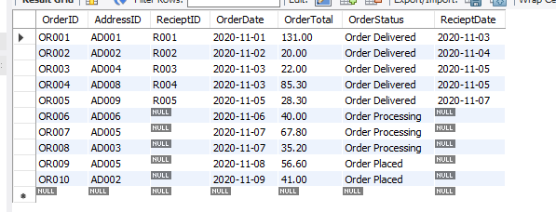

------------------------------------------------------------------------------------------------------------------------------------------

/*Creates the Shipment Table*/

CREATE TABLE Shipment(

ShipmentID varchar(255),

OrderID varchar(255),

DeliveryCompanyName varchar(30),

DeliveryDate date,

ShipmentWeight decimal(10,2),

CONSTRAINT pk_ShipmentID PRIMARY KEY(ShipmentID),

CONSTRAINT fk_OrderID FOREIGN KEY(OrderID) REFERENCES Orders(OrderID)

);

/*Load Shipment with data*/

INSERT INTO Shipment VALUES

("SH001", "OR001", "FedEx", "2020-11-03", 0.44);

INSERT INTO Shipment VALUES

("SH002", "OR002", "FedEx", "2020-11-04", 0.10);

INSERT INTO Shipment VALUES

("SH003", "OR003", "Aramex", "2020-11-05", 0.22);

INSERT INTO Shipment VALUES

("SH004", "OR004", "DHL", "2020-11-05", 0.47);

INSERT INTO Shipment VALUES

("SH005", "OR005", "Aramex", "2020-11-07", 0.22);

INSERT INTO Shipment VALUES

("SH006", "OR006", "DHL", null, 0.36);

INSERT INTO Shipment VALUES

("SH007", "OR007", "DHL", null, 0.27);

INSERT INTO Shipment VALUES

("SH008", "OR008", "FedEx", null, 0.30);

INSERT INTO Shipment VALUES

("SH009", "OR009", "Aramex", null, 0.44);

INSERT INTO Shipment VALUES

("SH010", "OR010", "DHL", null, 0.20);

/*Extract all records from Shipment table*/

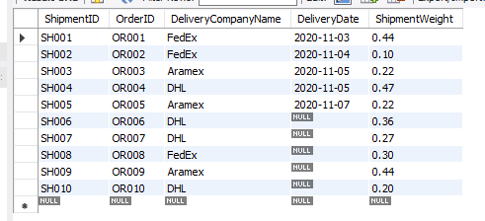SELECT * from Shipment;

------------------------------------------------------------------------------------------------------------------------------------------

/*Creates the Orders_Stock table*/

CREATE TABLE Orders_Stock(

OrderID varchar(255),

StockID varchar(255),

TotalQuantity int,

CONSTRAINT fk2_OrderID FOREIGN KEY(OrderID) REFERENCES Orders(OrderID),

CONSTRAINT fk_StockID FOREIGN KEY(StockID) REFERENCES Stock(StockID)

);

/*Load Orders_Stock with data*/

INSERT INTO Orders_Stock VALUES

("OR001", "S002", 2);

INSERT INTO Orders_Stock VALUES

("OR002", "S005", 1);

INSERT INTO Orders_Stock VALUES

("OR003", "S012", 2);

INSERT INTO Orders_Stock VALUES

("OR004", "S032", 1);

INSERT INTO Orders_Stock VALUES

("OR004", "S029", 1);

INSERT INTO Orders_Stock VALUES

("OR005", "S019", 1);

INSERT INTO Orders_Stock VALUES

("OR006", "S005", 2);

INSERT INTO Orders_Stock VALUES

("OR007", "S023", 3);

INSERT INTO Orders_Stock VALUES

("OR008", "S025", 1);

INSERT INTO Orders_Stock VALUES

("OR009", "S019", 2);

INSERT INTO Orders_Stock VALUES

("OR010", "S015", 2);

/*Extract all records from Orders_Stock table*/

SELECT * from Orders_Stock;

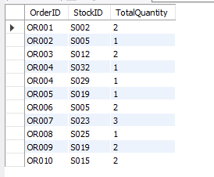

------------------------------------------------------------------------------------------------------------------------------------------

# **Appendixes**

## Appendix A

/*CREATE TABLE statement*/

/*Creates the Brand table*/

CREATE TABLE Brand(

BrandID varchar(255),

BrandName varchar(30),

CountryOfOrigin varchar(30),

CONSTRAINT pk_BrandID PRIMARY KEY(BrandID)

);

/*Creates the Supplier table*/

CREATE TABLE Supplier(

SupplierID varchar(255),

SupplierName varchar(60),

SupplierContactNo varchar(30),

SupplierAddress varchar(100),

SupplierCity varchar(30),

CONSTRAINT pk_SupplierID PRIMARY KEY (SupplierID)

);

/*Creates the Customer table*/

CREATE TABLE Customer(

CustomerID varchar(255),

CustomerName varchar(60),

CustomerContactNo varchar(30),

LoginEmail varchar(30),

LoginPassword varchar(25),

CONSTRAINT pk_CustomerID PRIMARY KEY(CustomerID)

);

/*Creates the Address table*/

CREATE TABLE Address(

AddressID varchar(255),

CustomerID varchar(255),

AddressDescription varchar(100),

AddressCity varchar(20),

PO_Box varchar(5),

AddressType varchar(20),

CONSTRAINT pk_AddressID PRIMARY KEY(AddressID),

CONSTRAINT fk_CustomerID FOREIGN KEY(CustomerID) REFERENCES Customer(CustomerID)

);

/*Creates the Product table*/

CREATE TABLE Product(

ProductID varchar(255),

BrandID varchar(255),

SupplierID varchar(255),

ProductDescription varchar(100),

ProductType varchar(20),

ProductGender varchar(20),

ProductPrice decimal(10,2),

CONSTRAINT pk_ProductID PRIMARY KEY(ProductID),

CONSTRAINT fk_BrandID FOREIGN KEY(BrandID) REFERENCES Brand(BrandID)

);

/*Creates the Stock table*/

CREATE TABLE Stock(

StockID varchar(255),

ProductID varchar(255),

StockColor varchar(20),

StockSize varchar(20),

StockQuantity int,

CONSTRAINT pk_StockID PRIMARY KEY(StockID),

CONSTRAINT fk_ProductID FOREIGN KEY(ProductID) REFERENCES Product(ProductID)

);

/*Creates the Orders table*/

CREATE TABLE Orders(

OrderID varchar(255),

AddressID varchar(255),

RecieptID varchar(255),

OrderDate date,

OrderTotal decimal(10,2),

OrderStatus varchar(30),

RecieptDate date,

CONSTRAINT pk_OrderID PRIMARY KEY(OrderID),

CONSTRAINT fk_AddressID FOREIGN KEY(AddressID) REFERENCES Address(AddressID)

);

/*Creates the Shipment Table*/

CREATE TABLE Shipment(

ShipmentID varchar(255),

OrderID varchar(255),

DeliveryCompanyName varchar(30),

DeliveryDate date,

ShipmentWeight decimal(10,2),

CONSTRAINT pk_ShipmentID PRIMARY KEY(ShipmentID),

CONSTRAINT fk_OrderID FOREIGN KEY(OrderID) REFERENCES Orders(OrderID)

);

/*Creates the Orders_Stock table*/

CREATE TABLE Orders_Stock(

OrderID varchar(255),

StockID varchar(255),

TotalQuantity int,

CONSTRAINT fk2_OrderID FOREIGN KEY(OrderID) REFERENCES Orders(OrderID),

CONSTRAINT fk_StockID FOREIGN KEY(StockID) REFERENCES Stock(StockID)

);

## Appendix B

/*INSERT INTO statement*/

/*Load Brand with data*/

INSERT INTO Brand VALUES

("B001", "Adidas", "Germany");

INSERT INTO Brand VALUES

("B002", "Puma", "Germany");

INSERT INTO Brand VALUES

("B003", "Levi’s", "United States");

INSERT INTO Brand VALUES

("B004", "Under Armour", "United States");

INSERT INTO Brand VALUES

("B005", "Nike", "United States");

INSERT INTO Brand VALUES

("B006", "Armani", "Italy");

INSERT INTO Brand VALUES

("B007", "Calvin Klein", "United States");

/*Extract all records from Brand table*/

SELECT * from Brand;

/*Load Supplier with data*/

INSERT INTO Supplier VALUES

("SU001", "Caramba", "0035316001000", "Caramba Headquarters, Abbey Street", "Dublin");

INSERT INTO Supplier VALUES

("SU002", "JD Sports", "0035321006321", "JD Sports Complex, St. Patrick Street", "Cork");

INSERT INTO Supplier VALUES

("SU003", "Next", "0035342305810", "The Wallace Building, Wellington Street", "Dundalk");

INSERT INTO Supplier VALUES

("SU004", "ELIE Wholesale", "0035314009393", "The Golden Tower, Amiens Street", "Dublin");

/*Extract all records from Supplier table*/

SELECT * from Supplier;

/*Load Customer with data*/

INSERT INTO Customer VALUES

("C001", "Conor James", "00353835674367", "conor.james@gmail.com", "Jamesalisson2020");

INSERT INTO Customer VALUES

("C002", "Cillian Anderson", "00353879648299", "cillian1989@outlook.com", "cillianA121*");

INSERT INTO Customer VALUES

("C003", "Riona Wilson", "00353867272829", "rionaw1986@yahoo.com", "Wilson.R86*");

INSERT INTO Customer VALUES

("C004", "Shane Pattinson", "00353833622445", "patto2020@outlook.com", "Pattinson88*");

INSERT INTO Customer VALUES

("C005", "Ciara Andrews", "00353832405373", "ciara2013@gmail.com", "CiaraFrancis2013");

INSERT INTO Customer VALUES

("C006", "Daniel McGregor", "00353853802023", "mdaniel1990@gmail.com", "dLeander2018*");

INSERT INTO Customer VALUES

("C007", "Cillian O’Brien", "00353871293223", "cillianob2001@yahoo.com", "obrienC2001*");

INSERT INTO Customer VALUES

("C008", "Shane Biden", "00353833833024", "shane.biden@gmail.com", "Shaneisthebest2001");

INSERT INTO Customer VALUES

("C009", "Brendan Franklin", "00353834941424", "franklinbrendan@outlook.com", "FrankBren1993*");

INSERT INTO Customer VALUES

("C010", "Grace Anderson", "00353855406832", "anderson.grace@gmail.com", "graceA1990*");

/*Extract all records from Customer table*/

SELECT * from Customer;

/*Load Address with data*/

INSERT INTO Address VALUES

("AD001", "C001", "The Dorms Building, Building No: 15, Room No: 201, Henry Street", "Dublin", null, "Residential");

INSERT INTO Address VALUES

("AD002", "C003", "Crown Company, Building No: 43, Shandon Street", "Cork", "38923", "Company");

INSERT INTO Address VALUES

("AD003", "C001", "Leyton Traders, Greenwood Building, Building No: 99, Amiens Street", "Dublin", "28289", "Company");

INSERT INTO Address VALUES

("AD004", "C004", "The Den, Building No: 92, Flat No: 117, 14th Baker Street", "Dublin", null, "Residential");

INSERT INTO Address VALUES

("AD005", "C008", "The Italian Knights Building, Building No: 10, Flat No: 204, Leinster Street", "Dundalk", null, "Residential");

INSERT INTO Address VALUES

("AD006", "C005", "Oaklands Building, Building No: 11, Room No: 303, Leinster Street", "Dundalk", "39923", "Residential");

INSERT INTO Address VALUES

("AD007", "C008", "Francesco and Sons, Building No: 94, Baggot Street", "Dublin", "12937", "Company");

INSERT INTO Address VALUES

("AD008", "C002", "The Old Barn, Building No: 23, Flat No: 109, 24-London Street", "Galway", null, "Residential");

INSERT INTO Address VALUES

("AD009", "C007", "Leyton Traders, Greenwood Building, Building No: 99, Amiens Street", "Dublin", null, "Company");

INSERT INTO Address VALUES

("AD010", "C002", "Frankston Building, Building No: 33, Flat No: 401, Thames Street", "Cork", "84834", "Residential");

/*Extract all records from Address table*/

SELECT * from Address;

/*Load Product with data*/

INSERT INTO Product VALUES

("P001", "B001", "SU002", "Adidas 20-21 FC Bayern Munich Away Jersey", "T-Shirt", "Male", 65.50);

INSERT INTO Product VALUES

("P002", "B003", "SU001", "Levi’s Penelope Denim Shirt", "Shirt", "Female", 20.00);

INSERT INTO Product VALUES

("P003", "B002", "SU002", "Puma Women's Amplified Fleece Hoodie", "Hoodie", "Female", 16.00);

INSERT INTO Product VALUES

("P004", "B003", "SU004", "Levi’s Men's Crewneck Graphic Short Sleeve T-Shirt", "T-Shirt", "Male", 11.00);

INSERT INTO Product VALUES

("P005", "B007", "SU003", "Calvin Klein Women’s Short Sleeve T-Shirt Monogram Logo", "T-Shirt", "Female", 20.50);

INSERT INTO Product VALUES

("P006", "B006", "SU001", "Armani Exchange Men's Crew Neck Logo Tee", "T-Shirt", "Male", 28.30);

INSERT INTO Product VALUES

("P007", "B003", "SU004", "Levi's Men's Brato Short Sleeve, Slim Fit, Solid Woven Shirt", "Shirt", "Male", 22.60);

INSERT INTO Product VALUES

("P008", "B004", "SU002", "Under Armour [Men's Tech Popover Hoodie](https://www.amazon.com/Under-Armour-1274511-Popover-Hoodie/dp/B00YSPQ5CU/ref=sr_1_9?crid=XCNF42QMN4N3&dchild=1&keywords=under+armour+hoodie+mens&qid=1606650929&sprefix=under+armour+hoo%2Caps%2C352&sr=8-9)", "Hoodie", "Male", 35.20);

INSERT INTO Product VALUES

("P009", "B002", "SU003", "Puma Unisex NRG Triblend Graphic T-Shirt", "T-Shirt", "Unisex", 25.30);

INSERT INTO Product VALUES

("P010", "B005", "SU002", "Nike 20-21 FC Barcelona Home Jersey", "T-Shirt", "Male", 60.00);

/*Extract all records from Product table*/

SELECT * from Product;

/*Load Stock with data*/

INSERT INTO Stock VALUES

("S001", "P001", "White", "Small", 20);

INSERT INTO Stock VALUES

("S002", "P001", "White", "Medium", 10);

INSERT INTO Stock VALUES

("S003", "P001", "White", "Large", 10);

INSERT INTO Stock VALUES

("S004", "P001", "White", "Extra Large", 0);

INSERT INTO Stock VALUES

("S005", "P002", "Blue", "Small", 10);

INSERT INTO Stock VALUES

("S006", "P002", "Blue", "Medium", 5);

INSERT INTO Stock VALUES

("S007", "P002", "Blue", "Large", 0);

INSERT INTO Stock VALUES

("S008", "P003", "Black", "Small", 10);

INSERT INTO Stock VALUES

("S009", "P003", "Black", "Medium", 10);

INSERT INTO Stock VALUES

("S010", "P003", "Black", "Large", 8);

INSERT INTO Stock VALUES

("S011", "P004", "White", "Small", 10);

INSERT INTO Stock VALUES

("S012", "P004", "White", "Medium", 10);

INSERT INTO Stock VALUES

("S013", "P004", "White", "Large", 5);

INSERT INTO Stock VALUES

("S014", "P004", "White", "Extra Large", 5);

INSERT INTO Stock VALUES

("S015", "P005", "White", "Small", 15);

INSERT INTO Stock VALUES

("S016", "P005", "White", "Medium", 10);

INSERT INTO Stock VALUES

("S017", "P005", "White", "Large", 5);

INSERT INTO Stock VALUES

("S018", "P006", "Black", "Small", 0);

INSERT INTO Stock VALUES

("S019", "P006", "Black", "Medium", 10);

INSERT INTO Stock VALUES

("S020", "P006", "Black", "Large", 12);

INSERT INTO Stock VALUES

("S021", "P007", "Pink", "Small", 0);

INSERT INTO Stock VALUES

("S022", "P007", "Pink", "Medium", 10);

INSERT INTO Stock VALUES

("S023", "P007", "Pink", "Large", 10);

INSERT INTO Stock VALUES

("S024", "P008", "Gray", "Small", 0);

INSERT INTO Stock VALUES

("S025", "P008", "Gray", "Medium", 10);

INSERT INTO Stock VALUES

("S026", "P008", "Gray", "Large", 5);

INSERT INTO Stock VALUES

("S027", "P009", "White", "Small", 0);

INSERT INTO Stock VALUES

("S028", "P009", "White", "Medium", 1);

INSERT INTO Stock VALUES

("S029", "P009", "White", "Large", 2);

INSERT INTO Stock VALUES

("S030", "P010", "Red", "Small", 2);

INSERT INTO Stock VALUES

("S031", "P010", "Red", "Medium", 5);

INSERT INTO Stock VALUES

("S032", "P010", "Red", "Large", 2);

/*Extract all records from Stock table*/

SELECT * from Stock;

/*Load Orders with data*/

INSERT INTO Orders VALUES

("OR001", "AD001", "R001", "2020-11-01", 131.00, "Order Delivered", "2020-11-03");

INSERT INTO Orders VALUES

("OR002", "AD002", "R002", "2020-11-02", 20.00, "Order Delivered", "2020-11-04");

INSERT INTO Orders VALUES

("OR003", "AD004", "R003", "2020-11-03", 22.00, "Order Delivered", "2020-11-05");

INSERT INTO Orders VALUES

("OR004", "AD008", "R004", "2020-11-03", 85.30, "Order Delivered", "2020-11-05");

INSERT INTO Orders VALUES

("OR005", "AD009", "R005", "2020-11-05", 28.30, "Order Delivered", "2020-11-07");

INSERT INTO Orders VALUES

("OR006", "AD006", null, "2020-11-06", 40.00, "Order Processing", null);

INSERT INTO Orders VALUES

("OR007", "AD005", null, "2020-11-07", 67.80, "Order Processing", null);

INSERT INTO Orders VALUES

("OR008", "AD003", null, "2020-11-07", 35.20, "Order Processing", null);

INSERT INTO Orders VALUES

("OR009", "AD005", null, "2020-11-08", 56.60, "Order Placed", null);

INSERT INTO Orders VALUES

("OR010", "AD002", null, "2020-11-09", 41.00, "Order Placed", null);

/*Extract all records from Orders table*/

SELECT * from Orders;

/*Load Shipment with data*/

INSERT INTO Shipment VALUES

("SH001", "OR001", "FedEx", "2020-11-03", 0.44);

INSERT INTO Shipment VALUES

("SH002", "OR002", "FedEx", "2020-11-04", 0.10);

INSERT INTO Shipment VALUES

("SH003", "OR003", "Aramex", "2020-11-05", 0.22);

INSERT INTO Shipment VALUES

("SH004", "OR004", "DHL", "2020-11-05", 0.47);

INSERT INTO Shipment VALUES

("SH005", "OR005", "Aramex", "2020-11-07", 0.22);

INSERT INTO Shipment VALUES

("SH006", "OR006", "DHL", null, 0.36);

INSERT INTO Shipment VALUES

("SH007", "OR007", "DHL", null, 0.27);

INSERT INTO Shipment VALUES

("SH008", "OR008", "FedEx", null, 0.30);

INSERT INTO Shipment VALUES

("SH009", "OR009", "Aramex", null, 0.44);

INSERT INTO Shipment VALUES

("SH010", "OR010", "DHL", null, 0.20);

/*Extract all records from Shipment table*/

SELECT * from Shipment;

/*Load Orders_Stock with data*/

INSERT INTO Orders_Stock VALUES

("OR001", "S002", 2);

INSERT INTO Orders_Stock VALUES

("OR002", "S005", 1);

INSERT INTO Orders_Stock VALUES

("OR003", "S012", 2);

INSERT INTO Orders_Stock VALUES

("OR004", "S032", 1);

INSERT INTO Orders_Stock VALUES

("OR004", "S029", 1);

INSERT INTO Orders_Stock VALUES

("OR005", "S019", 1);

INSERT INTO Orders_Stock VALUES

("OR006", "S005", 2);

INSERT INTO Orders_Stock VALUES

("OR007", "S023", 3);

INSERT INTO Orders_Stock VALUES

("OR008", "S025", 1);

INSERT INTO Orders_Stock VALUES

("OR009", "S019", 2);

INSERT INTO Orders_Stock VALUES

("OR010", "S015", 2);

/*Extract all records from Orders_Stock table*/

SELECT * from Orders_Stock;